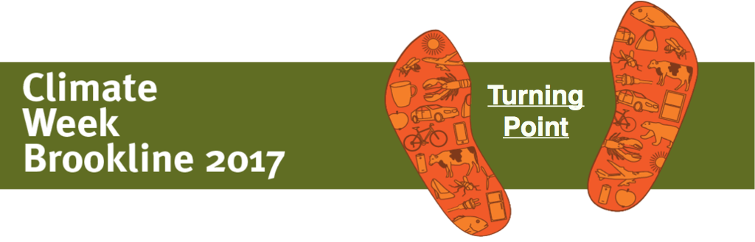TAKING ACTION NOW after Climate Week 2017
Climate Week Brookline 2017 is designed to keep climate progress going forward with determined action by citizens at grass roots levels despite federal level retrenchment. What follows is a list of actions individuals can take to continue forward progress. These actions involve personal activity and activity that impacts the political process at the local, state, and national levels. See Climate Action Brookline (CAB) www.climateactionbrookline.org for details.

Personal Engagement
- Reduce your carbon footprint – Mass Save home audits? 100% Mass Energy Wind?
Healthy garden soil? Plant trees? New technologies? Electric vehicle?
- Stay informed and donate to climate organizations and candidates local, state, national
- Invest? Divest? Get a green credit card? Is your bank green?
- Join a house of worship, or a secular organization that advocates for social/political/environmental issues at local/state/national levels.
Some (not an exhaustive list) examples of local Brookline orgs include:
Climate Action Brookline www.climateactionbrookine.org
Mothers Out Front Brookline www.mothersoutfrontbrooklinema.nationbuilder.com
Brookline GreenSpace Alliance www.brooklinegreenspace.org
Friends of the Muddy River www.themuddyriver.wordpress.com

Actions Focused at the local level
- Run for a position in your town. In Brookline, run for Town Meeting Member; two Town Meetings per year; 16 precincts with 15 Town Meeting Members per prec. (3 yr. term)
- Run for Town Selectman (5 Selectman each with 3 year terms)
- Submit or contribute to Warrant Articles before Town Meeting
- Attend open public meetings/hearings – of Selectmen, schools, town committees.
- Many Town Committee members are not elected officials but appointed. www.brooklinema.gov/27/Government

Actions Focused at the state level
- Join organizations. Some (not an exhaustive list) examples of state orgs are:
Environment Massachusetts www.environmentmassachusetts.org
350MA www.350mass.org
Massachusetts Climate Action Network www.massclimateaction.org (CAB is a member)
Mass Energy www.massenergy.org
Mass Power Forward www.mapowerforward.com/join-the-fight (CAB is a member)
Mothers Out Front www.mothersoutfront.org/massachusetts
Progressive Dems of Mass www.progressivedemsofmass.org
Resist the Pipeline www.resistthepipeline.org
Soil4Climate, www.soil4climate.org
EldersClimateAction,www.eldersclimateaction.org
League of Women Voters, wv.org/get-involved/local-leagues/massachusetts
Environmental Voter Project, www.environmentalvoter.org
- Work with MA Power Forward, a coalition of 150 organizations around the state. Join the MA Power Forward lobby days & energy bill hearings. Call your state reps and senators and governor. Write letters to the editor, social media, Facebook & Twitter
www.malegislature.gov/Events/Hearings/www.house.gov/representatives, www.malegislature.gove/People/Senate, www.Mass.gov
- Run for MA State Representative or MA Senator, or other elected state offices. For Brookline see http://www.brooklinema.gov/135/Elected-Officials
- Apply for open positions in state government. See http://www.mass.gov/anf/employment-equal-access-disability/masscareers/masscareers.html

Actions Focused at the national level
- Attend events/marches in Washington DC or local sister events. This April 29th -www.peoplesclimate.org/ Washington DC/Boston
- Join organizations. Some (not an exhaustive list) examples of orgs (that also have local or state chapters) are: -350.org, www.350.org -Sierra Club, www.sierraclub.org -Union of Concerned Scientists www.ucsusa.org -Progressive Democrats Of America www.pdamerica.org
- Call legislators, email, sign petitions on behalf of national climate groups. www.usa.gov/elected-officials/
- Donate to in state and out of state candidates who advocate climate policies.
- Apply for open positions in Federal government located locally. www.federalgovernmentjobs.us/job-location/massachusetts-ma.html

